Becoming a Student Led Opportunity Guide

Student Led Community Projects What you need to Know.
SLCP’s are not currently specified within the Bye Laws except for reference within the Code of Conduct Guidance as being required to adhere to the Code of Conduct.
SLCP’s are not represented within any formal committee structures or formally reflected in the remit of any officer roles. Historically the activities officer has informally included SLCP’s as part of the wider ‘student group’ community.
Once formed SCLP’s follow some society procedures in terms of being recognised as a student group, this includes committee paperwork (registering committee members, risk assessments etc.), new committee training, core funding application and access to development funds.
SLCP Process
- Student/s have an idea about setting up a project – Is referred or self refers to Communities team.
- Meeting arranged with community coordinator to discuss the idea and explain the difference between a SLCP and a society – Students choice which route they would like to take.
- Community coordinator talks through the criteria and process for becoming a SLCP – If the student/s evidence they fulfil the SLCP criteria and requirements they are encouraged to complete relevant paperwork.
- Once registration paperwork complete and checked by the community coordinator– student/s required to follow relevant society processes.
If an idea is presented that appears to duplicate an existing SLCP or covers areas of activity that an existing society does, the student/s would be advised to connect with that group or review their proposal.

SLCP Criteria
Historically Student Led Projects were set up in response to student requests. Student Led Projects are groups of students with an idea or initiative that focus on a group of people other than their own members; for example a Community Group or a Charity Group, acting almost like miniature charities of their own. We have decided to call them Student Led Community Projects as of 2021!
The group must be started by a current student at The University of Nottingham, have a Project leader and treasurer. But aside from that the project is completely Student Led.

Criteria Case Study – Idea or Initiative
In November 2013 a student came into the volunteer centre and said’ I have an idea for a project’. By May 2014 the UoN Community First Responders were a registered SLP and have gone from strength to strength.
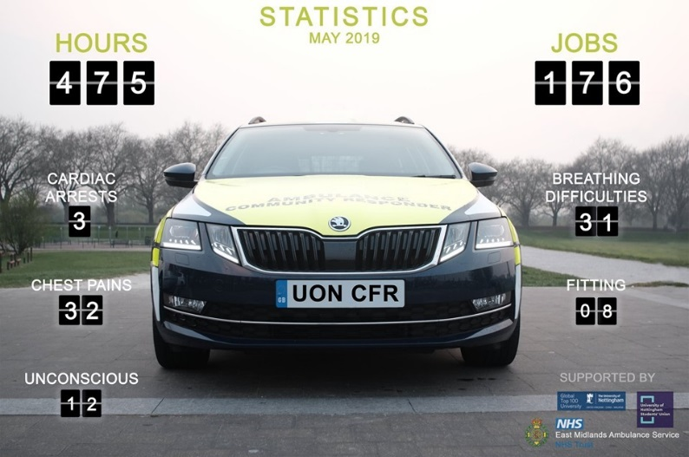

Criteria Case Studies – Benefiting Others
SLCP’s can have life changing impacts on those groups they support, they also provide developmental opportunities for students involved and frequently address for example; social inequalities, civic and environmental social responsibilities.

SLCP Requirements
- Does not duplicate something that already exists
- Providing a service or volunteering that is wanted and/or needed
- Has clear aims & objectives with defined key activities
- Has a project leader/president and a treasurer and any other project leadership structure that fits the group’s needs.
- Has a clear project set up plan (volunteers, budgets, identified training & support needs, publicity etc.).
- Demonstrates a plan for sustainability year on year
- Funding – start-up costs, match funding (can be in kind), fundraising and consideration as to possible income and expenditure
Alongside meeting/s with a community coordinator a registration form is completed to demonstrate the above.

Expectations of SLCP’s (Once approved)
- All student groups must abide by our Code of Conduct https://www.su.nottingham.ac.uk/resources/Societies/Code-of-Conduct/
- We ask Student Led Community Projects to be sustainable; they will run from year to year.
- The previous project leader will provide a comprehensive handover.
- To Recruit a Project leader and a treasurer.
- Decide the leadership structure of the project depending on what is relevant for your project.
- The Project will attend a compulsory initial SU development meeting and Health and Safety training.
- The Project will abide by SU policies, i.e. Equality and Diversity policy, alcohol at events policy etc.
- The Project will submit event forms for every event, and if necessary a budget and event plan.
- Produce relevant Public Liability insurance (food at events etc.)
- Provide an up to date list of active volunteers for our records.
- Produce a risk assessment for the project and any large events.
- Use only the SU bank account for in goings / outgoings.
- Show evidence of match funding / fundraising.
- Keep the relevant volunteer coordinator up to date on any significant changes within the group.

Additional differences between SLCP’s and Societies
SLCP’s are not required to charge membership, this is in recognition that the groups are not for the benefit of members and are giving their time, knowledge etc. to benefit others.
SLCP’s are not required to hold AGM’s but are encouraged to hold regular meetings as a committee and a with members.
SLCP’s are not required to have constitutions, there registration form documents their aims & objectives, leadership structure, key activities etc.
SLCP’s do not run elections to select their leadership members, how they do this is defined within their project registration.

Recommendations
Affiliation - SLCP’s affiliation remains as above with the addition of requesting the Activities Officer to be involved in the initial meeting and signing SLCP registration approval with relevant coordinator.

Representation – SLCP members have access to representation on an individual basis, the same level as any Union member. To date not having specific representation has not been raised as an issue. Student group core processes SLCP’s adhere to are governed and represented within Societies Council and other relevant democratic forums, but SLCP’s do not feed into that. Activities Officer to consider the impact of representation and suggest any actions/considerations. We are happy to support a focus group with SLCP members to explore this further.

Any questions email studentcommuities@uonsu.com

