If you require any support with your event contact
Victoria Cameron on: Victoria.cameron@nottingham.ac.uk
Event Plan
Club/Society/Media Group
Date of Event
Venue

The following event plan can be used as a base for your own event plan. Delete and add titles as appropriate to your event, and include as much detail as possible.

Event Details
Name:
Venue:
Date:
Times:

Expected attendance:

Overview of Event
Please write a detailed account of what your event entails including any aims and objectives.

Contingency plan
You need a contingency plan in case of bad weather.

Contact Information
Add all useful contact numbers here for organisers, venue, third parties, photographers etc.
Main Point of contact | Name
 | Contact number
 | Email Address

Venue Contact | Name
 | Contact number
 | Email Address

Please add more columns as appropriate

Order of Events
Example of order of events
(make this as detailed as possible)

10:00 | Event set up team arrive
10:15 | Chairs, table and staging set up
12:00 | Media groups to set up equipment
13:00 | Doors open
13:30 | Performance begins
14:00 | Interval
14:15 | Dance act

Venue Requirements and Floor Plan
IMPORTANT: Off campus venue documents - please make sure you send the venues Risk Assessment and PLI to your event coordinator.
Before you sign a contract and pay a deposit for the venue, all contracts must be sent to Julia.beeson@nottingham.ac.uk
Example: Make sure you detail where stalls, acts, food vendors, inflatables etc. are going to go.
Venue to be cleared by 1am
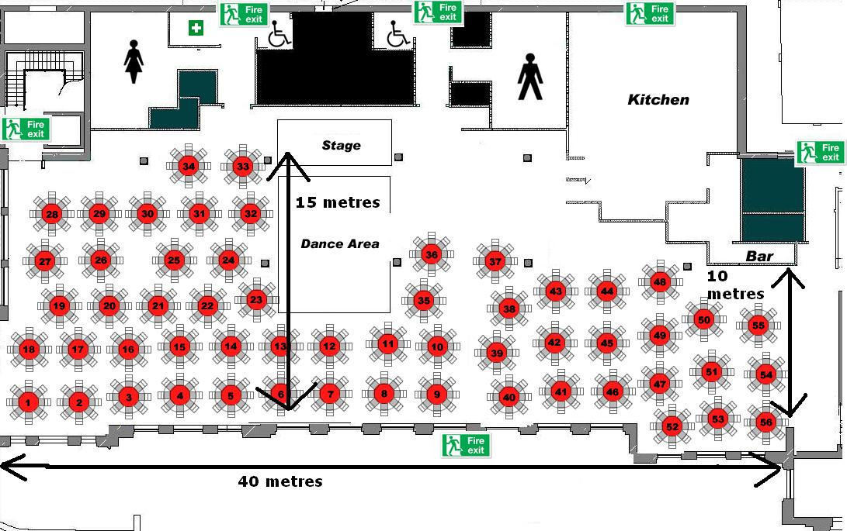

NOTE: If you require equipment such as tables, chairs, backing boards and bins please email your Events Coordinator.

Running order
This is the main document your event team will work from – it’s advisable to print this off separately also and ensure everyone has a copy.
TIME |  | ACTION | RESPONSIBLE

Example
Xia Bury (XB), Simon Hopkins (SH), Gary Cully (GC), Katherine Phipps (KP), Jules Lediard (JL), Holly Roberts (HR), Maria Brown (MB), Tom Hicks (TH), Paddy Atkinson (PA), Richard Whiston (RW), Chris Pavey (CP), Danny Harrsion (DH) Glynn Dignum (GD), AU exec, Lemar Francois (Photographer)
TIME |  | ACTION | RESPONSIBLE
10:00 |  | Camera crane to be set up + media groups to arrive | Media Groups
11:00 |  | Simon Hopkins to sign out Keys – key issued to SH, XB, SF | SH
11:30 |  | Core event staff to arrive | XB, SH, KP, GC, JL
11:30 | 12:00 | Walk through of Arena (led by Xia) | XB, KP, GC, RW
12:00 | 13:00 | Set up of banners in corridors, set up of hanging banner above merchandise stall (UoN), set up of sponsor tables, Cheque to ice entrance, any other kit | XB, KP, GC
12:00 |  | Media Access to suites | All media groups
14:30 |  | Cheerleaders Arrive
15:00 | 18:20 | Cheerleaders Practice – stage to be cleared by 18:20 (JL to ensure cleared) | JL
16:30 |  | Sponsor to set up | GC
16:30 |  | Holly to arrive with Mascot | HR
16:30 |  | Chris Pavey to set up camera at side of ice (media slot) | JL, CP, RW
17:00 |  | Sponsor 2 to arrive and set up | GC
17:00 |  | Promoter to arrive and set up | KP
17:15 |  | DJ set to begin
17:30 | 18:15 | Pre skate – all players + mascot to be on ice
17:00 | 17:45 | Core event team Food break – organisers office | XB, SH, JL, HR, DH, SF,GC, KP
17:45 | 18:00 | Briefing – Glynn + Maria + Holly – organisers office | XB, KP, GD, MB, HR
18:00 | 18:15 | PRE-EVENT BRIEFING – ALL EVENT STAFF TO ATTEND – GREEN ROOM | XB, KP, GC, MB, GD, HR, AU EXEC, (ALL EVENT STAFF)
18:00 | 18:15 | Photographer to arrive – Rich to meet and give tour of Arena | RW
18:15 |  | DKH charity to arrive + Ross Davenport (Athlete) – Holly to meet charity and issue buckets – advise where to stand + take to suites | HR
18:15 | 19:45 | Maria Brown to oversee merchandise, ticket sales + ticket collection | MB
18:15 | 19:45 | 2 x AU exec to merchandise stand – assisting Student clubber with sale of merchandise | 2 x AU exec
18:15 | 19:45 | 4 x AU exec on stand near panther shop – selling basketball tickets (Basketball players to direct sales to stand) | 4 x AU exec
18:15 | 19:45 | 2 x AU exec on VIP door | 2 x AU exec
18:15 | 19:45 | 3 x AU exec on ticket collection desk | 3 x AU exec
18:15 |  | 1 x AU exec runner (to be with Xb, SH and KP) on level 1 by ice | 1 x AU exec
18:15 | 19:45 | Suite management – ensuring VIPs are allocated correct suites, ensuring all catering orders are correct, on hand to deal with any issues | HR
18:20 | 18:30 | Players / Coaches / Refs briefing - Green Room | SH, XB
18:30 |  | DOORS OPEN | XB
18:50 |  | All players + mascots to Zambini gates | SH, DH
18:55 |  | DJ change – URN to Mark Cooper | SH, XB
19:10 | 19:30 | Collect Mike from Headway Charity | XB
19:10 | 19:30 | Collect SU Presidents from suite | KP
19:30 | 19:35 | Briefing to President and charity | XB, KP, SH
19:25 |  | Amy Harmer – stand by Zambini GAtes | SH, DH
19:30 | 19:34 | Amy Harmer – performance | SH, DH
19:34 | 19:38 | Players on ice – laps and line up
19:38 | 19:40 | Red carpet rolled out on ice – players intros are announced
19:42 | 19:43 | Charity Presentation | SU presidents, Mike from Headway
19:43 |  | 1 x AU exec runner – take president + charity back to suites | 1 x Au exec
19:45 | 20:15 | Face off – 1st period
20:15 | 20:21 | Under 12s
20:30 | 21:00 | 2nd Period
20:30 | 20:45 | Sponsor stalls tear down | GC
20:40 |  | Tom and Paddy to be by ice entrance | TH, PA
21:00 | 21:05 | Shoot the puck competition | TH, PA
21:00 | 21:05 | PHOTOS REQUIRED | Photographer
21:00 | 21:06 | Cheerleaders ready to go on stage | XB, SH
21:06 | 21:15 | Cheerleaders battle performance
21:06 | 21:15 | PHOTOS REQUIRED | Photographer
21:15 | 21:50 | 3rd Period
21:15 |  | Collect all banners and promotional material and any leftover merchandise | XB, KP, GC, HR, JL,

Roles and Responsibilities
Initials | Name | Role/Organisation | Email | Mobile
AmS |  | Organiser
TW |  | Organiser

Security and Stewarding
- State here if you are having or require paid security (your event coordinator will advise you how many - don’t forget to update the event plan with number of staff and times.)
- If security is included with venue also put this here along with how many are included.
- If you are having stewards and volunteers, then please outline how many and their role on the day here. The Health and Safety team will advise you if you have enough volunteers for your event.

Post event clean up
Please do not put ‘we will clear up the next morning’ we expect to see a cleaning plan in place. If you have booked cleaners or porter staff, then please state this here.

If the society or club are conducting the cleaning – PLEASE ACCOUNT FOR THIS IN THE RISK ASSESSMENT UNDER ‘POST EVENT CLEAN UP’

Catering and External Companies
Include Caterers details here.
Include menu choice

Include External Company details here:
Include items that have been hired e.g., inflatables, Spotify van

NB// Ensure you have a copy of the caterers Public Liability Insurance as this will be requested by the Students’ Union

Performance
Include all performers contact details
Running order
Stage manager details

Photography
Photographer:
Contact number:
Arrival Time:
Photos required:

Media
Include details of any media groups covering your event – access times, who they will report to etc.

Emergency Procedures
Event organisers are responsible for ensuring that they are aware of and are able to implement emergency procedures if required.
NOTE: You should check with your venue what their emergency procedures are and detail them down in this section.
Please contact susafety@nottingham.ac.uk if you need further advice.

First Aid
It is the responsibility of event organisers to ensure that there is adequate first aid provision for their event.
This may need to be a professional first aid company for larger or more complex events.
Please contact susafety@nottingham.ac.uk for any advice on first aid.
NOTE: If your event is taking place inside you must book a room out beforehand - this can be done through SU reception.

Room allocation
Include all room allocations
Room | Who?

Kit List
List all the equipment you will need to take to your event and who is responsible for taking and returning the equipment
Example
KIT ITEM | STAFF RESPONSIBLE
Ice Hockey Trophy | Simon Hopkins
Mascot | Holly Roberts
Pull up banners, Price Lists, Hanging banner, | Xia, Julia
Foam fingers | Promoter
T shirts | Xia, Victoria, Julia Morley
Tables x 3 Sponsors - UPP, Teach first, | Gary Cully
Charity buckets | Holly
Tickets – suite, general admission, Basketball tickets | Holly
Floats x 3 | Maria
Money Bags | Maria
Signage for Basketball Tickets | Xia, Victoria, Julia Morley

